* width
* height
* margin
* margin-top
* margin-left
* margin-right
* margin-bottom
* padding
* padding-top
* padding-left
* padding-right
* padding-bottom
* border
* border-top
* border-left
* border-right
* border-bottom

Note:

* padding is inside the border
* margin is outside the border

Se puede usar 3 distintas opciones para **margin / border / padding**

* margin: 20px;
* margin-top: 20px; margin-right: 20px; margin-left:20px; margin-bottom: 20px;
* margin 20px 20px 20px 20px; **// top – right – bottom - left**

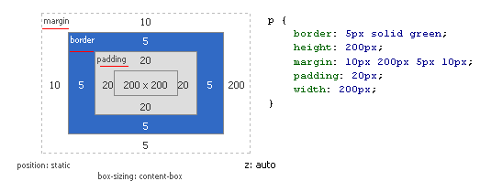

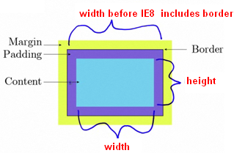

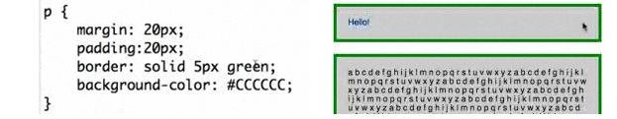

**IMPORTANT**

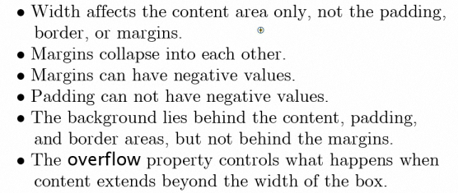

**IMPORTANT: OVERLAP MARGINS, margin collapse into each other. Margins is yellow, outside border**

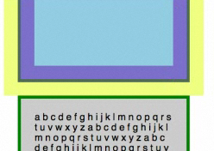

**USING OVERFLOW**

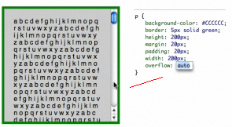

**USING FIREBUG**

<html>

<head>

<style>

p {

margin-top: 20px;

margin-right: 200px;

margin-bottom: 5px;

margin-left: 10px;

padding:20px;

border: solid 5px green;

background-color: #CCCCC;

width: 200px;

height: 200px;

}

</style>

</head>

<body>

<p id="dd">

Hello!

</p>

<p id="dd2">

adfasdfdasfasdfsdfsdfsdafdsafsadfsd Hello!

</p>

</body>

</html>

